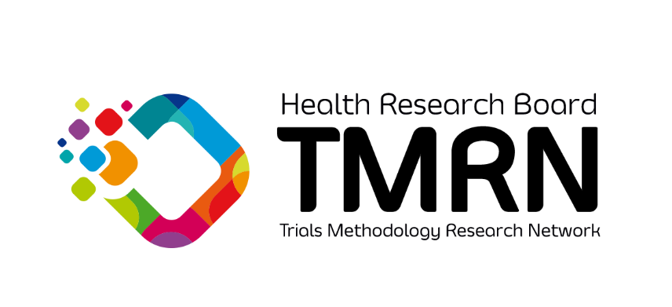
HRB-TMRN Training Funding Scheme

2022 - 2026
Application Form

Note: this call will remain open subject to funding availability. Applicants must read the associated guidance notes for this call.

Applications must be completed and submitted by email to hrb-tmrn@universityofgalway.ie with “HRB-TMRN Training Funding Scheme” in the subject line. Applications will receive a response within 3 weeks of application.

Application Form

Please complete ALL SECTIONS using font Calibri, size 11pt with single line spacing.

It is the responsibility of each applicant to check the word count in each section. Failure to comply within the word counts may result in your application being deemed ineligible without further review.

Completed applications can be submitted by email as a PDF to
HRB-TMRN@universityofgalway.ie; noting TRAINING AWARD in the subject line.

Details of the Lead Applicant:
Applicant name
Title (Mr., Ms., Dr., Prof. etc.)
Current role
Institution / Organisation
Address
Contact phone number
E-mail

Details of the Co-applicants: (please copy and paste table to add further Co-applicants)
Applicant name
Title (Mr., Ms., Dr., Prof. etc.)
Current role
Institution / Organisation
Address
Contact phone number
E-mail

Title of proposed training event:

Summary Outline (200 words max)
Please present a short background and description of the event, including the name of the event, dates and duration. The summary should also state the amount of funding that is requested.

Aim (50 words max)
Identify the aim of the event in relation to the promotion and / or education of trial methodology activity

Learning outcomes (200 words max)
Identify the learning outcomes of the event

Potential Impact of the Activity (200 words max)
Clearly outline the potential impact of the activity for health research, information or policy in Ireland, including potential public impact. For example, explain the extent to which the event may inform practice, influence policy, engage the public or generate public debate or media coverage.

Provide full available programme if available.
Insert link to online programme here, or attach programme separately.

Budget (max. €2000)
The budget requested must reflect the scale and nature of the proposed activities and reviewers will thoroughly assess the level of funds requested when reviewing the proposal. Please provide a detailed breakdown of the proposed spend for this event.

Requested budget amount: €

HRB-TMRN TRAINING FUNDING SCHEME 2022 - 2026 SIGNATURE PAGE

Applicant

I am submitting this application to the HRB-TMRN to be considered for funding under the HRB-TMRN TRAINING FUNDING award call. I confirm that I have read the Guidance Notes for the call and that I will acknowledge the source of funding in any subsequent promotions or publications arising from this work.

Signature: ____________________________________ Date:___________________

Name (Printed): ____________________________________

Head of School / Department / Unit (if not lead applicant)

I have read this application and the relevant Guidance Notes. I confirm that I am aware that the lead applicant is seeking funding to run the proposed event.

Signature: ____________________________________ Date:___________________

Name (Printed): ____________________________________

